

College of Arts and Sciences

186 University Hall
230 North Oval Mall
Columbus, OH 43210

Phone (614) 292-1667
Fax (614) 292-8666
Web artsandsciences.osu.edu

9 November 2010

Lawrence Krissek, Professor of Earth Sciences
Faculty Chair, Committee on Curriculum and Instruction
College of the Arts and Sciences

Dear Larry,

The Disciplinary Advisory Panel from Arts and Humanities of the College of Arts and Sciences met and reviewed proposals on Wednesday, November 3, 2010. The committee unanimously endorsed two proposed revisions for the BA in Music and the BM in Composition in Music. We are asking that you expedite these proposals through the curricular review process at ASC CCI and to CAA as quickly as possible. The revisions are for the quarter versions of our BA in Music and BM in Composition programs.

The School of Music, along with the other arts units, offer accredited tagged degree programs. The tagged degree programs in the arts were first approved by CAA in May of 1991 and revisions were made to the BA Core in Music and the BM and BME in Music and approved by CAA on April 20, 2008.

In 2008, the School of Music created its self-study and hosted the external reviewers for its site visit from our accrediting body, National Associate of the Schools of Music (NASM). NASM’s report identified two curricular problems: the lack of performance/applied study opportunities within the BA in Music and the perceived lack of composition experiences for our composition majors within the BM in Composition. Under new leadership from Associate Director, Timothy Leasure, he has presented a solution to the problem, the School of Music faculty have voted to approve his proposal, and now we are submitting it for curricular review and approval.

The summation of the changes are as follows:

BA in Music: The credit hours for the total major of 181 remain unchanged. The School of Music added to its current 6 credit hours in applied study, 6 hours taken from the open electives category and moved 3 credit hours from the music theory category into the applied study at the 201 level (6 credits) and at the 401 level (6 credits). This is a change from 67 credit hours in the major under quarters to 73 credit hours in the major still under quarters. The addition of the 6 credit hours will allow the School of Music to be in compliance with the NASM standards throughout the rest of our quarter offerings of the program. Please note: The semester version of this degree will be 47 semester credit hours which is within the range of 2/3 reduction plus or minus 4 credits from the original 67. These additional credit hours are only until Summer 2012. Due to the re-shaping and re-organization of the course work in Music, this is not an accreditation issue under the semester version.

BM in Music Composition: The credit hours for the total major of 182 remain unchanged. The School of Music moved the Composer’s Seminar courses into the Music Theory and Composition area, deleting 3 credit hours from the Ensembles side of the advising sheet and placing them on the Music Theory and Composition side of the advising sheet. They also took the 10 credit hours that were open music electives for their composition students and placed them in the Music Theory and Composition area to include courses in Composition 2 for 6 credits and one additional Senior Composition Project experience of 4 credits. The rearrangement of the 13 credit hours will allow the School of Music to be in compliance with the NASM standards.

If you have any questions or concerns, please do not hesitate to call or email me at 292-5727 or williams.1415@osu.edu.

Thank you for your consideration and fast-tracking of these proposals,
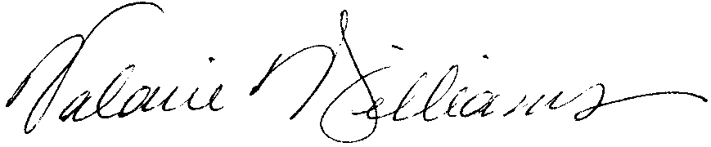
Valarie Williams
Professor of Dance
Associate Dean, College of Arts and Sciences, Arts and Humanities

CC: Mark Shanda, Interim Divisional Dean, Arts and Humanities and Professor of Theatre
Timothy Leasure, Associate Director of the School of Music and Associate Professor of Music
Rick Blatti, Interim Director of the School of Music and Professor of Music

